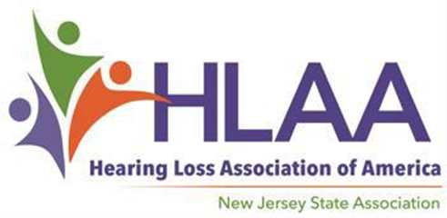

2022 Scholarship Award Program

For Audiology Doctoral Students

You are encouraged to apply if…

Doctoral Student

Scholarship Applications Available at Hearingloss-nj.org

An Application consists of a Form,
Letters of Reference….
and an Essay — Get started now!

Submission Deadline

May 22, 2022

For more information, visit HLAA- NJ website:

Hearingloss-nj.org

Questions? Contact Latisha Porter-Vaughn, Scholarship Chair Latisha.Porter-Vaughn@hearingloss-nj.org
♦ You are a full-time audiology

♦ You are a New Jersey resident

♦ You plan to continue your education in Fall 2022...

1 Scholarship @ $1500 each — thanks to funds raised at the annual HLAA Walk4Hearing, held in October 2021 in West Windsor, NJ.
- The Winner will be awarded on Sunday, June 5 at the East Brunswick Library in East Brunswick, NJ from 1:30 PM – 4:00 PM.

