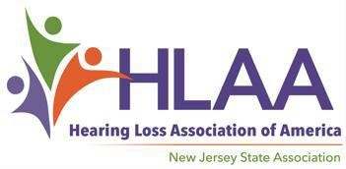

LETTER OF REFERENCE FOR HLAA-NJ SCHOLARSHIP

Applicant:_________________________________________________E-mail:______________________________

Evaluator’s Name:______________________________________________________________________________

Relationship of Evaluator to Applicant (teacher, employer, etc.):_________________________________________

How long and under what circumstances have you known the Applicant?__________________________________
____________________________________________________________________________________________

To the Evaluator: Please comment on the candidate’s academic strengths and weaknesses, social and emotional maturity. Describe the qualities of the applicant that you believe will enable the Applicant to succeed in college or vocational school.

Please return this page with your Letter of Reference to Latisha Porter-Vaughn, Chair of the HLAA-NJ Scholarship Committee online to Latisha.Porter-Vaughn@hearingloss-nj.org, with the Applicant’s name in the subject line, before the deadline, May 22, 2022. Do not hesitate to contact us with any other questions or concerns about writing or submitting the Letter of Reference. Thank you, --your time and input are sincerely appreciated!

About the HLAA-NJ Scholarships: HLAA-NJ is awarding one scholarship in the amount of $1500. Funding for this 2022 Scholarship is made possible by the annual fundraiser, the Garden State Walk4Hearing event, held in October 2021. Additional copies of the complete Scholarship Application can be found at www.hearingloss-nj.org

