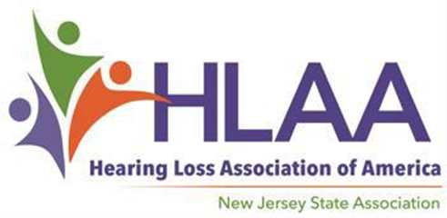

2023 Scholarship Award Program

For High School Seniors with Hearing Loss

You are encouraged to apply if…

Scholarship Applications Available at Hearingloss-nj.org

An Application consists of a Form,
Letters of Reference….
and an Essay — Get started now!

Submission Deadline

April 1, 2023

For more information, visit HLAA- NJ website:

Hearingloss-nj.org

Questions? Contact Latisha Porter-Vaughn, Scholarship Chair Latisha.Porter-Vaughn@hearingloss-nj.org
Miatalking2002@gmail.com
♦ You are a high school senior
with hearing loss…

♦ You are a New Jersey resident,
17-20 years old…

♦ You plan to continue your education in Fall 2023...

♦ You are ambitious and determined not to let
hearing loss get in the way of
your dreams!

2 Scholarships @ $2,000 each on behalf of The Hearing Society established in 1931.

*3 Scholarships for high school seniors @ $1,200

*1 Scholarship for a graduating Audiologist @ $1,200

Winners will be honored in May at our Scholarship Social which will be held at the East Brunswick Library…date and time to follow.

*Many thanks to funds raised at the annual HLAA Walk4Hearing, held on October 2022 in West Windsor, NJ.

