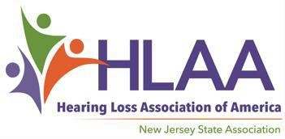

LETTER OF REFERENCE FOR HLAA-NJ SCHOLARSHIP

Applicant:_________________________________________________E-mail:______________________________

Evaluator’s Name:______________________________________________________________________________

Relationship of Evaluator to Applicant (teacher, employer, etc.): _________________________________________

How long and under what circumstances have you known the Applicant? __________________________________
____________________________________________________________________________________________

To the Evaluator: Please comment on the candidate’s academic strengths and weaknesses, social and emotional maturity. Describe the qualities of the applicant that you believe will enable the Applicant to succeed in college or vocational school.

Please return this page with your Letter of Reference to Latisha Porter-Vaughn, Chair of the HLAA-NJ Scholarship Committee online to Miatalking2002@gmail.com, with the Applicant’s name in the subject line, before the deadline, April 1, 2023. Do not hesitate to contact us with any other questions or concerns about writing or submitting the Letter of Reference. Thank you, --your time and input are sincerely appreciated!

About the HLAA-NJ Scholarships: HLAA-NJ is awarding up to three scholarships in the amount of $1200 each to deserving students with hearing loss to support their post-secondary school education and one $1,200 scholarship for a graduating Audiologist. Funding for these 2023 Scholarships is made possible by the annual fundraiser, the Garden State Walk4Hearing event, held in October 2022. Two $2,000 scholarships are being awarded on behalf of The Hearing Society, established in 1931 to provide education programs for children with hearing loss and their families. Additional copies of the complete Scholarship Application can be found at https://www.hearingloss-nj.org/ .

