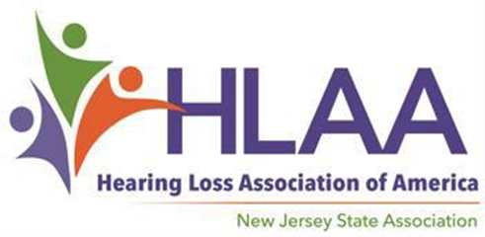

2022 Scholarship Award Program

For High School Seniors with Hearing Loss

You are encouraged to apply if…

Scholarship Applications Available at Hearingloss-nj.org

An Application consists of a Form,
Letters of Reference….
and an Essay — Get started now!

Submission Deadline

May 22, 2022

For more information, visit HLAA- NJ website:

Hearingloss-nj.org

Questions? Contact Latisha Porter-Vaughn, Scholarship Chair Latisha.Porter-Vaughn@hearingloss-nj.org
♦ You are a high school senior
with hearing loss…

♦ You are a New Jersey resident,
17-20 years old…

♦ You plan to continue your education in Fall 2022...

♦ You are ambitious and determined not to let
hearing loss get in the way of
your dreams!

2 Scholarships @ $2500 each on behalf of The Hearing Society established in 1931
4 Scholarships @ $1500 each — thanks to funds raised at the annual HLAA Walk4Hearing, held in October 2021 in West Windsor, NJ.
Winners will be awarded on Sunday, June 5at the East Brunswick Library in East Brunswick, NJ from 1:30 PM – 4:00 PM

