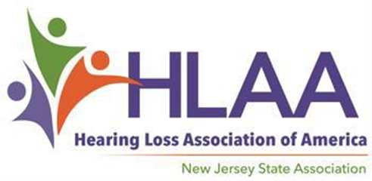

2019 Scholarship Award Program

For High School Seniors with Hearing Loss

You are encouraged to apply if…

Scholarship Applications Available at Hearingloss-nj.org

An Application consists of a Form,
Letters of Reference….
and an Essay — Get started now!

Submission Deadline

May 1, 2019

For more information, visit HLAA- NJ website:

Hearingloss-nj.org

Questions? Contact Latisha Porter-Vaughn, Scholarship Chair Latisha.Porter-Vaughn@hearingloss-nj.org
♦ You are a high school senior
with hearing loss…

♦ You are a New Jersey resident,
17-20 years old…

♦ You plan to continue your education in Fall 2019...

♦ You are ambitious and determined not to let
hearing loss get in the way of
your dreams!

2 Scholarships @ $2500 each on behalf of The Hearing Society established in 1931
4 Scholarships @ $1500 each — thanks to funds raised at the annual HLAA Walk4Hearing, held in October 2018 in West Windsor, NJ — will be awarded in June 2019 (time and place TBA).

