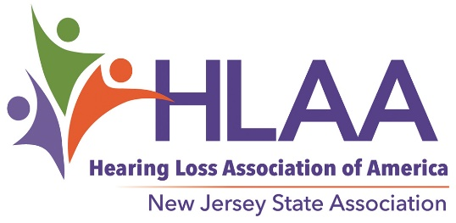

2018 Scholarship Award Program

For High School Seniors with Hearing Loss

You are encouraged to apply if…

Scholarship Applications Available at Hearingloss-nj.org

An Application consists of a Form,
Letters of Reference….
and an Essay — Get started now!

Submission Deadline

May 1, 2018

For more information, visit
HLAA- NJ website:

Hearingloss-nj.org

Questions? Contact Chair, Latisha Porter-Vaughn

Latisha.Porter-Vaughn@hearingloss-nj.org
♦ You are a high school senior
with hearing loss…

♦ You are a New Jersey resident,
17-20 years old…

♦ You plan to continue your education in Fall 2018...

♦ You are ambitious and determined not to let
hearing loss get in the way of
your dreams!

Up to 4 Scholarships @ $1500 each — thanks to funds raised at the annual HLAA Walk4Hearing, held in October 2017 in West Windsor, NJ — winners will be awarded in June 2018 (time and place TBA).

