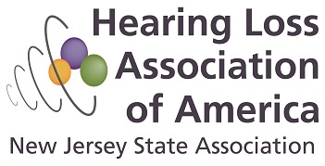

LETTER OF REFERENCE FOR HLAA-NJ SCHOLARSHIP

Applicant:_________________________________________________E-mail:______________________________

Evaluator’s Name:______________________________________________________________________________

Relationship of Evaluator to Applicant (teacher, employer, etc.):_________________________________________

How long and under what circumstances have you know the Applicant?__________________________________
____________________________________________________________________________________________

To the Evaluator: Please comment on the candidate’s academic strengths and weaknesses, social and emotional maturity. Describe the qualities of the applicant that you believe will enable the Applicant to succeed in college or vocational school.

Please return this page with your Letter of Reference to Latisha Porter-Vaughn, Chair of the HLAA-NJ Scholarship Committee online to Latisha.Porter-Vaughn@hearingloss-nj.org, with the Applicant’s name in the subject line, before the deadline, May 1, 2017. Do not hesitate to contact us with any other questions or concerns about writing or submitting the Letter of Reference.
Thank you --your time and input is sincerely appreciated!

About the HLAA-NJ Scholarships: The Hearing Loss Association of America (HLAA website: www.hearingloss.org) is a volunteer, international organization for people with hearing loss, their families and friends. The Hearing Loss Association of New Jersey (HLAA-NJ website: www.hearingloss-nj.org) is a non-profit, non-sectarian educational organization devoted to the welfare and interest of those who cannot hear well but are committed to participating in the hearing world. HLAA-NJ is awarding up to four scholarships in the amount of $1500 each to deserving students with hearing loss to support their post-secondary school education. Funding for the 2017 Scholarships is made possible by the annual fundraiser, the Garden State Walk4Hearing event, in October 2016. Additional copies of the complete Scholarship Application can be found at www.hearingloss-nj.org .

